**Order Suppot** (<https://magento.abmgood.com/support/index/Suporder/>):

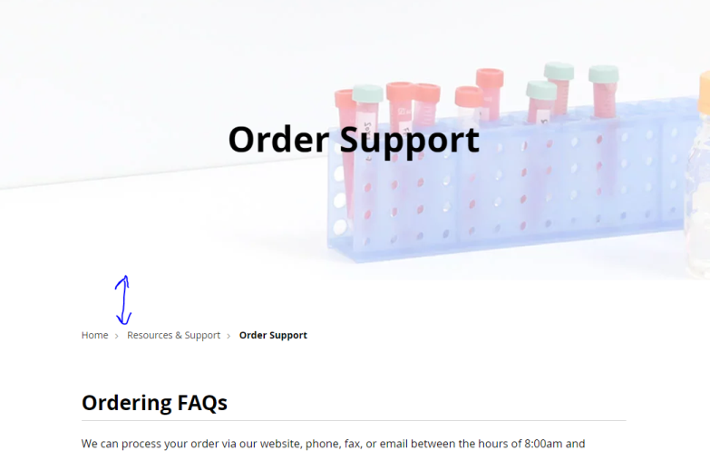 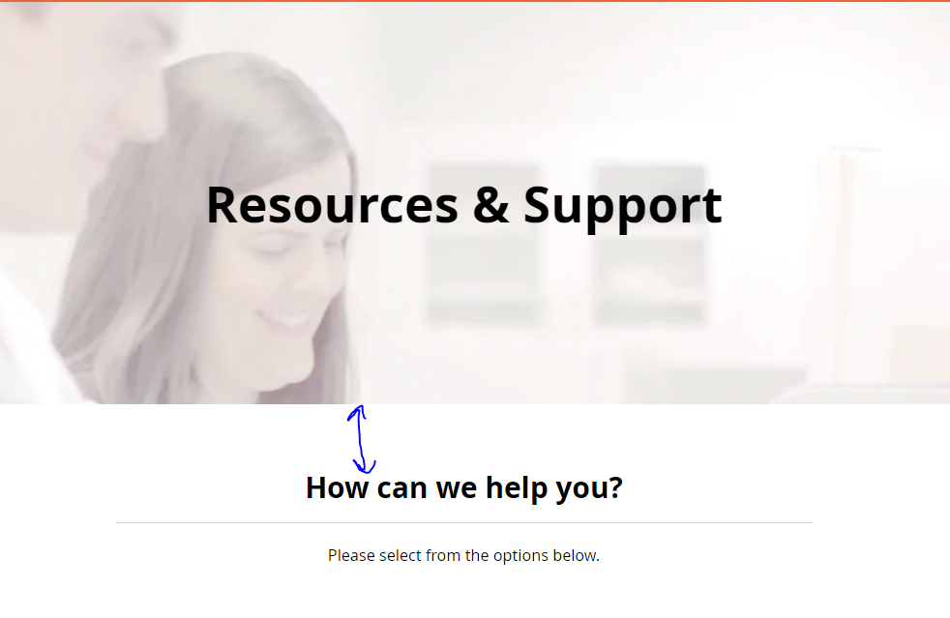

1. Match spacing highlighted in blue with the amount of space in the Resources & Support page.
   1. When I tested it in Chrome’s Inspector tool, it looks like it matches if:
      1. Set margin-top for the breadcrumbs to 0
      2. Changed div class="OrderSupportDiv" padding-top from 50px to 30px

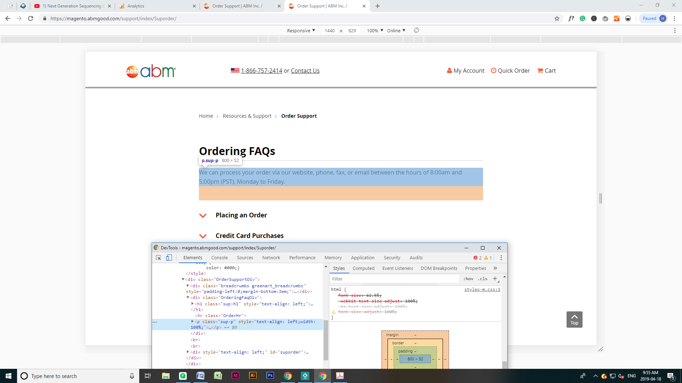

1. Remove the padding-bottom highlighted in orange above for the paragraph in all 3 sections on the page:
   1. Ordering FAQs
   2. Shipping your samples to abm
   3. Couldn’t find the answer to your questions?

**A:**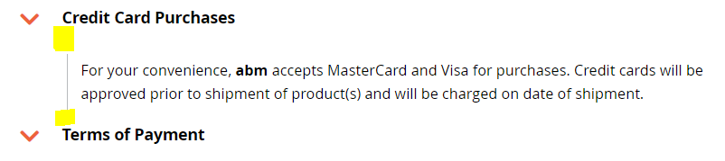

**B:**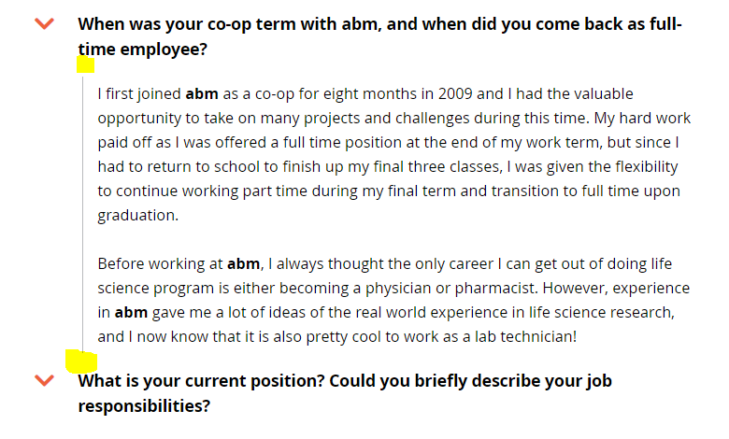

1. Make the vertical spacing highlighted in yellow in A (from Order Support page) match B (from Careers – Stories page - <https://magento.abmgood.com/careers/index/stories>)

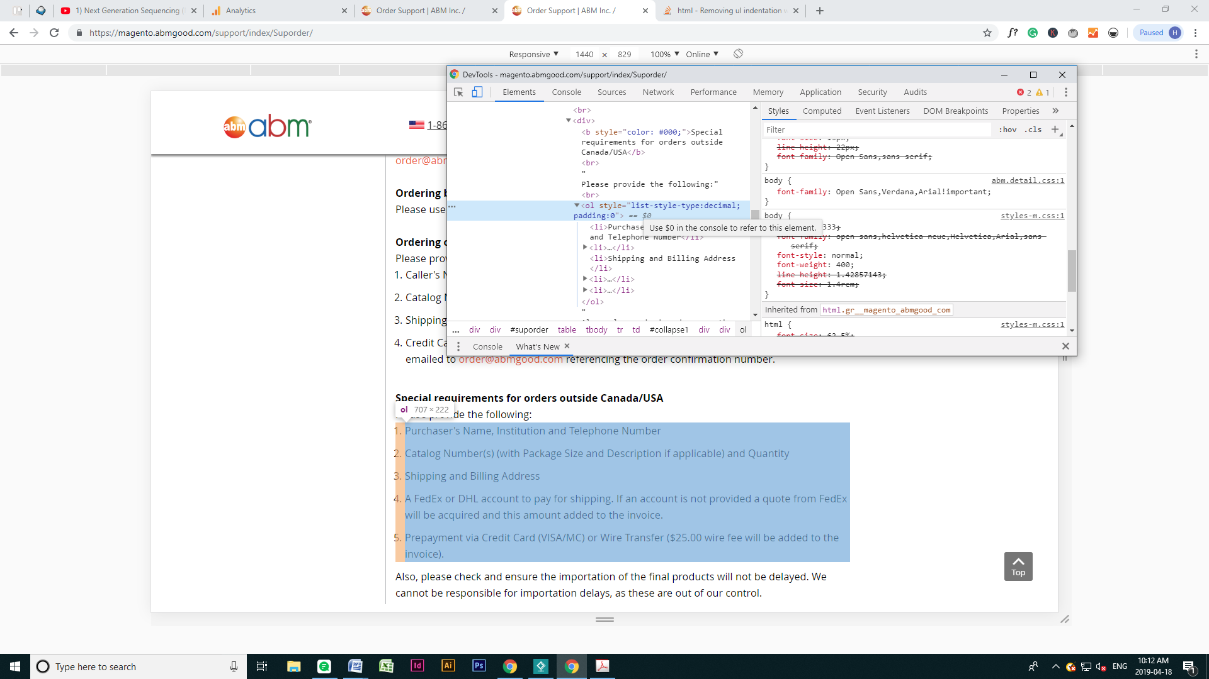

1. The numbers in the list sticks out on the left hand side. It looks like adding a padding-left of 3px fixes this on desktop, but I’m not sure if there’s a more optimal way to fix this for all screen sizes.
2. Add extra spacing (10px) between “Please provide the following:” and the numbered list.

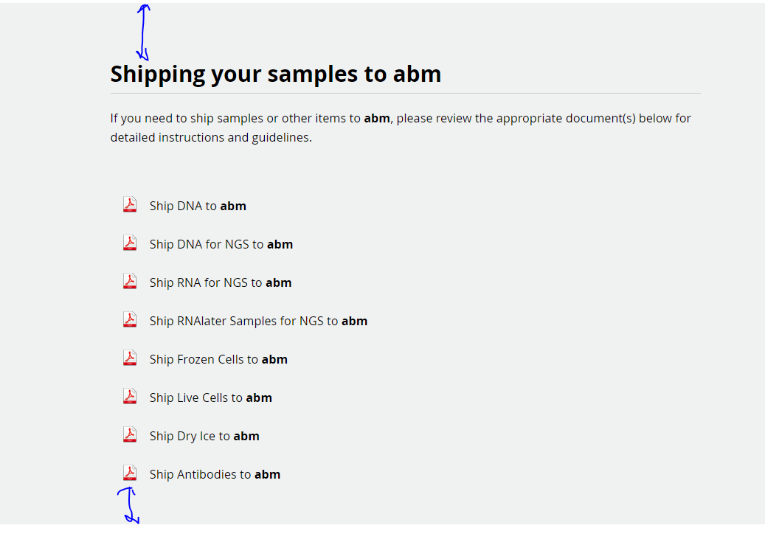

1. Match the space on the bottom with the amount of space at the top (highlighted by blue arrows).

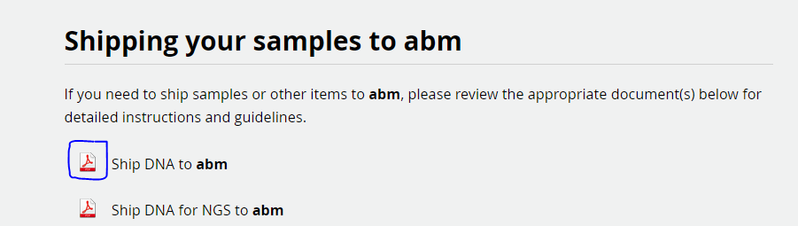

1. Make the PDF icons also a clickable link.

*More edits on the next page.*

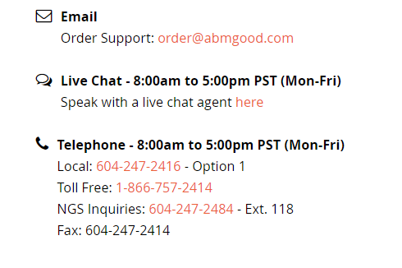

1. Icons (change color, increase size, and vertically align to text):
   1. color: #808083
      1. icons generally this color instead of black
   2. font-size: 1.35em
   3. padding-top: 4px
2. Text (increase space between icon and text):
   1. padding-left: 15px